The EU-US ATLANTIS Program
The ATLANTIS Program is a joint project of the U.S. Department of Education and the European Commission that supports transatlantic cooperation between institutions of higher education in the United States and Europe. The objectives of Atlantis include the facilitation of student and faculty exchange programs, the development of joint/dual degree programs, and an exchange of best practices in higher education administration.

Our Team Project
The University of Toledo and Owens Community College team project focuses on the study of short-cycle higher education degree programs (SCHE) in Europe and the United States, and on the role of short cycle education in addressing social and economic needs. Our European partners are the International University College, in Bulgaria, and LEIDO in the Netherlands. Short-Cycle Higher Education encompasses the level of studies beyond secondary education which can lead to a qualification recognized on the labor market (OECD) such as the associate degrees or certificate programs.

Our Partnership
All project partners will organize three international conferences designed to build bridges and strategic alliances between 2-year and 4-year institutions of higher education in the US and Europe. The first conference in Golden Sands, Bulgaria, will focus on the recognition and accreditation of SCHE programs and the alignment of educational systems to facilitate student exchange and meet global workforce needs. The second conference in Toledo, Ohio, highlights the role of SCHE in regional economic development. The third conference in Amsterdam, The Netherlands, focuses on the contribution of SCHE to life-long learning systems and the education, training, and development of knowledge workers in a global economy.

Contacts
The University of Toledo | Owens Community College
Snejana Slantcheva–Durst, Asst. Prof.  snejana.slantcheva-durst@utoledo.edu  David Meabon, Assoc. Prof.  david.meabon@utoledo.edu | Gretchen Carroll, Prof. gretchen_carroll@owens.edu  Paul Unger, Provost  paul_unger@owens.edu
Beth Scheufler, Grant Coordinator
The University of Toledo, Ohio, USA
Judith Herb College of Education
2801 W. Bancroft Street
Toledo, Ohio 43606-3390
419.530.2461 Phone 419.530.4912 Fax
elizabeth.scheufler@utoledo.edu
http://atlantis.utoledo.edu
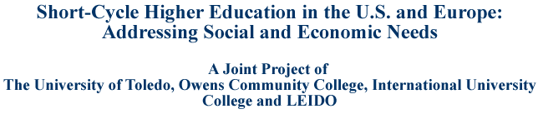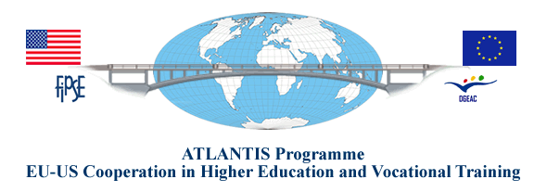

International Symposium on
Short-Cycle Higher Education
in the United States and Europe:
Educational Partnerships for
Economic and Community
Development

October 15-17, 2009

Owens Community College, Audio Visual Center
Toledo, Ohio, USA
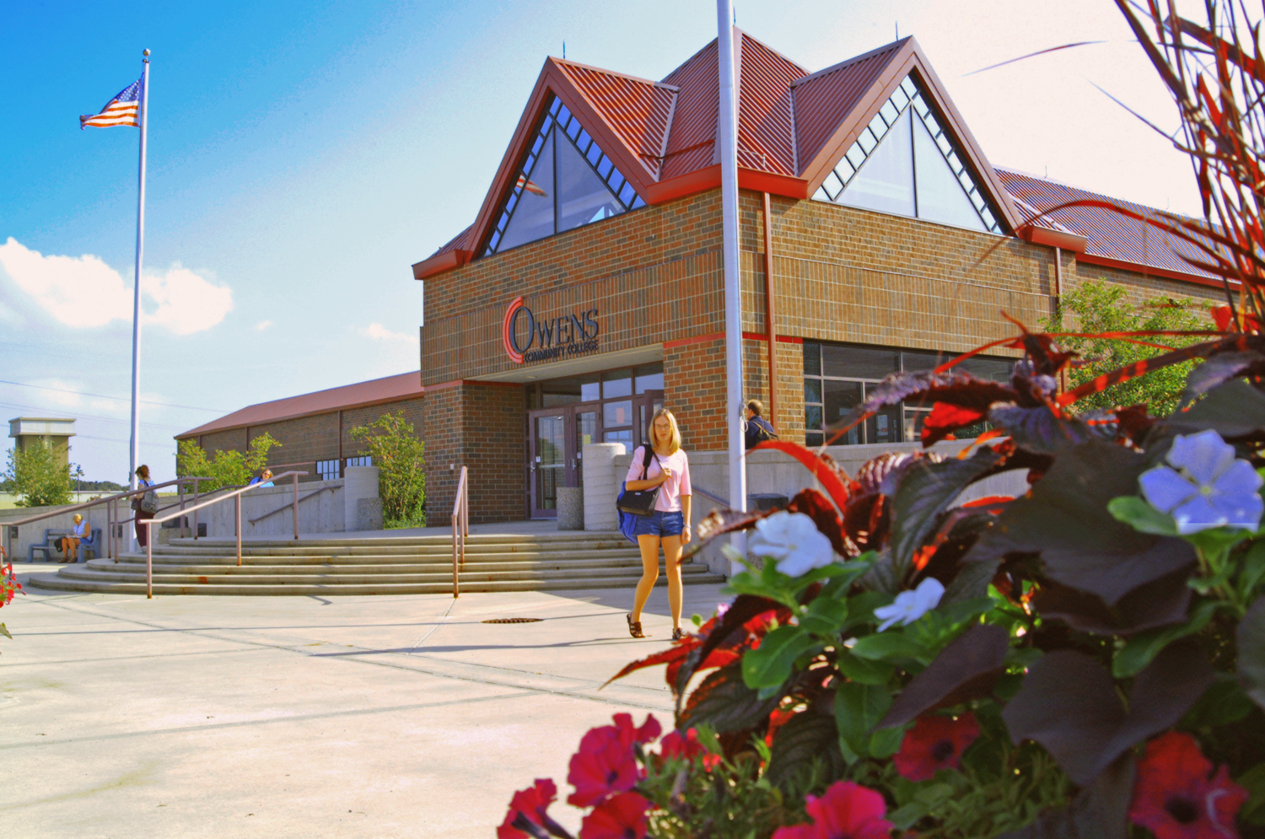
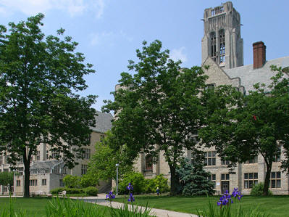

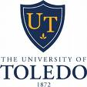
http://atlantis.utoledo.edu

…in Amsterdam for Our
3rd International Conference
The Contribution of SCHE to Life-Long and Life-Wide Learning Systems: Best Practices from Europe and the U.S.

Amsterdam, The Netherlands
June, 2010


National Innovation & Expertise
Center for Lifelong Learning
…Or visit Our Site for Our
Past 1st Conference

Recognition and Accreditation of Short-Cycle higher Education Programs in Europe and the U.S.: Aligning Educational Systems

Golden Sands, Varna, Bulgaria
June 15-17, 2009



International University College
Dobrich, Bulgaria
Join Us
Join Us

…in Toledo for Our
2nd International Conference

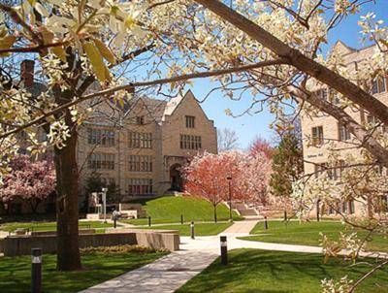
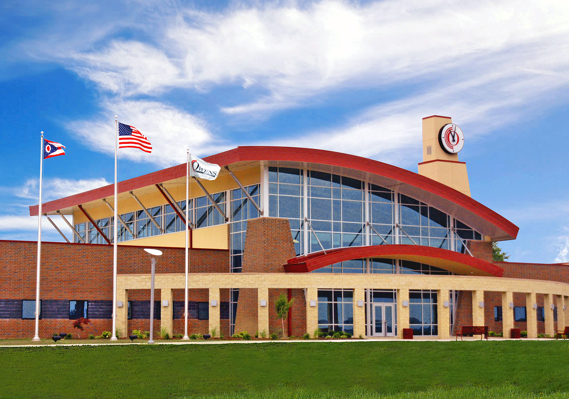
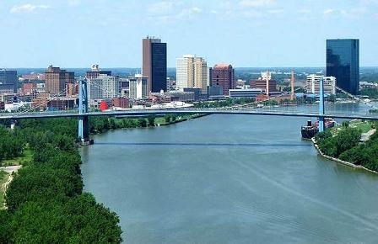

October 15-17, 2009
Short-Cycle Higher Education in the U.S. and Europe: Educational Partnerships for Economic and Community Development

Registration available at http://atlantis.utoledo.edu
Symposium Venue: Owens Community College, Audio Visual Center, 30335 Oregon Road, Perrysburg, Ohio 43551
Symposium Hotel: Hilton Garden Inn, 6165 Levis Commons Blvd., Perrysburg, Ohio 43551

